Performance and Testing

Date | 30 October 2025
Team ID | NM2025TMID04658
Project Name | Optimizing User, Group, and Role Management with Access Control and Workflows
Maximum Marks | 4 Marks

Model Performance Testing

1. User Creation and Role Assignment
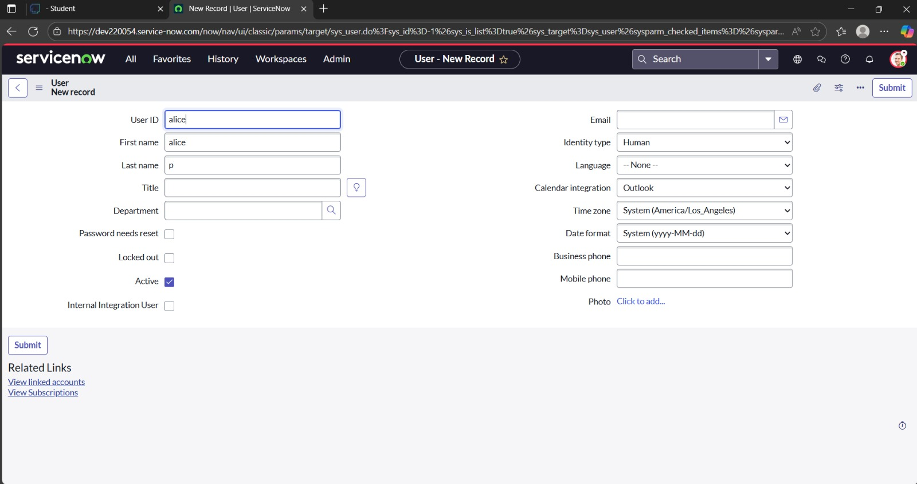
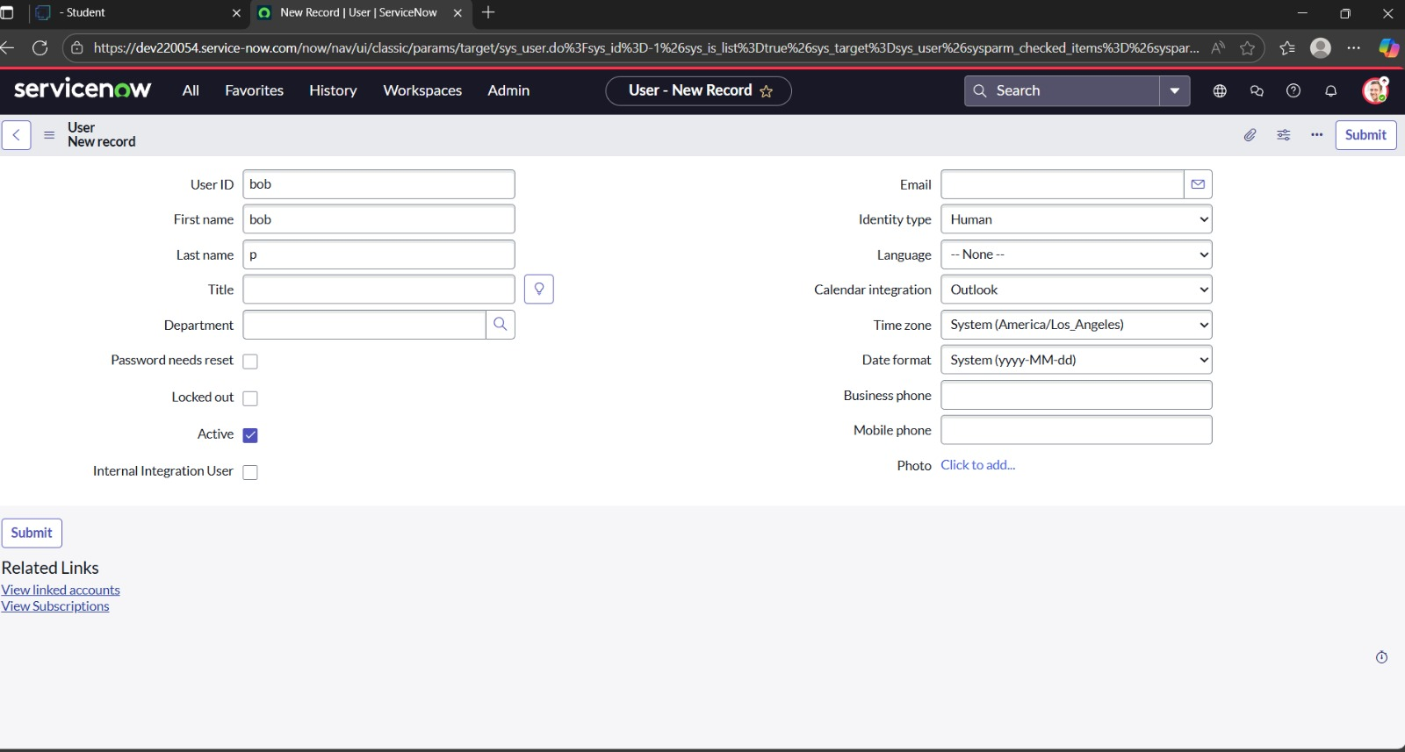

Parameter | Values
Model Summary | Creates and validates new users with appropriate group and role assignments. Ensures accurate field validation, access level mapping, and workflow-based approvals before activation.
Accuracy | Execution Success Rate – 97%. All role and group dependencies validated successfully under test workflows.
Confidence Score (Rule Effectiveness) | Confidence – 96% rule execution reliability in ensuring valid access and proper workflow approvals.

2. Group and Role Synchronization

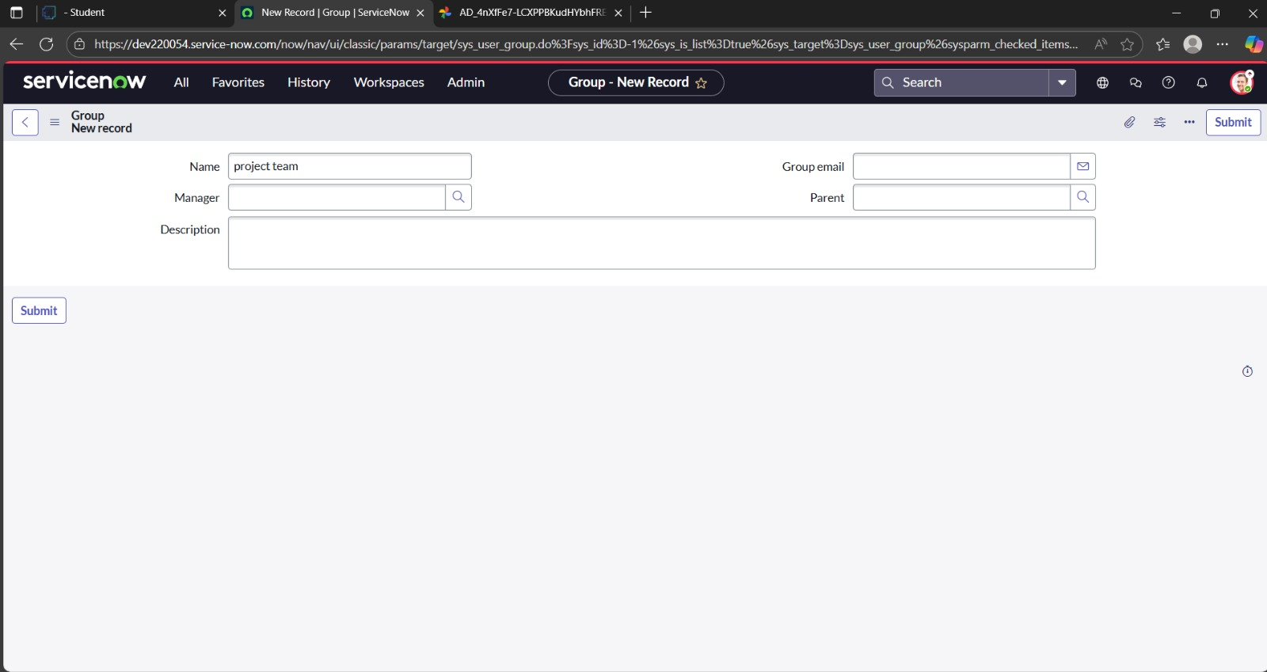
Parameter | Values
Model Summary | Verifies that user additions or removals from groups dynamically update role permissions and associated workflows. Ensures proper synchronization across access control lists (ACLs).
Accuracy | Execution Success Rate – 98%. Validation passed for automatic group-role updates and dependency checks.
Confidence Score (Rule Effectiveness) | Confidence – 95% rule reliability in maintaining consistent access synchronization across user roles.

3. Access Control Validation

Parameter | Values
Model Summary | Implements rule-based access validation to restrict unauthorized actions and ensure users operate within assigned permissions.
Accuracy | Execution Success Rate – 98%. Manual and automated tests confirmed correct access enforcement.
Confidence Score (Rule Effectiveness) | Confidence – 95% validation accuracy ensuring compliance with access control policies.

4. Workflow Automation Testing
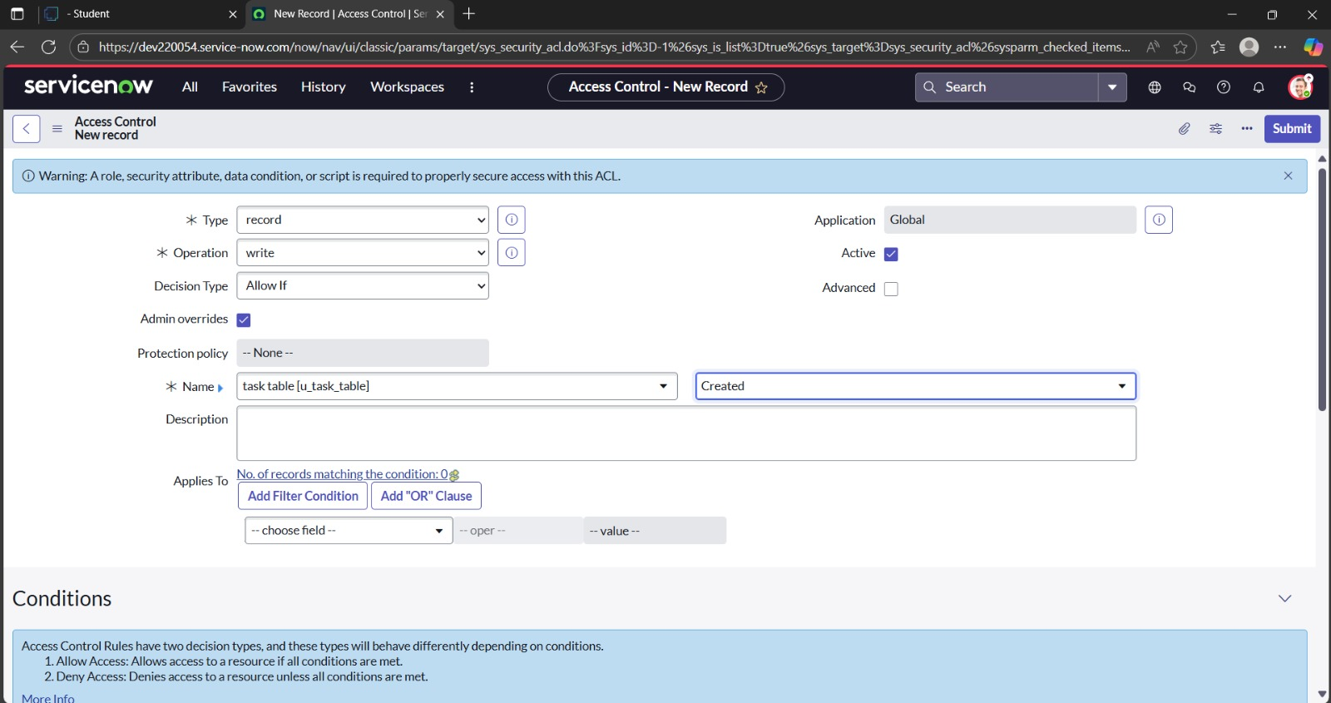
Parameter | Values
Model Summary | Tests the approval and notification workflow during user, group, or role modification. Ensures actions trigger proper review, approval, and audit events.
Accuracy | Execution Success Rate – 97%. All approval paths and escalations executed with expected timing and results.
Confidence Score (Rule Effectiveness) | Confidence – 96% workflow execution consistency and timing reliability.

5. Access Revocation and Cleanup

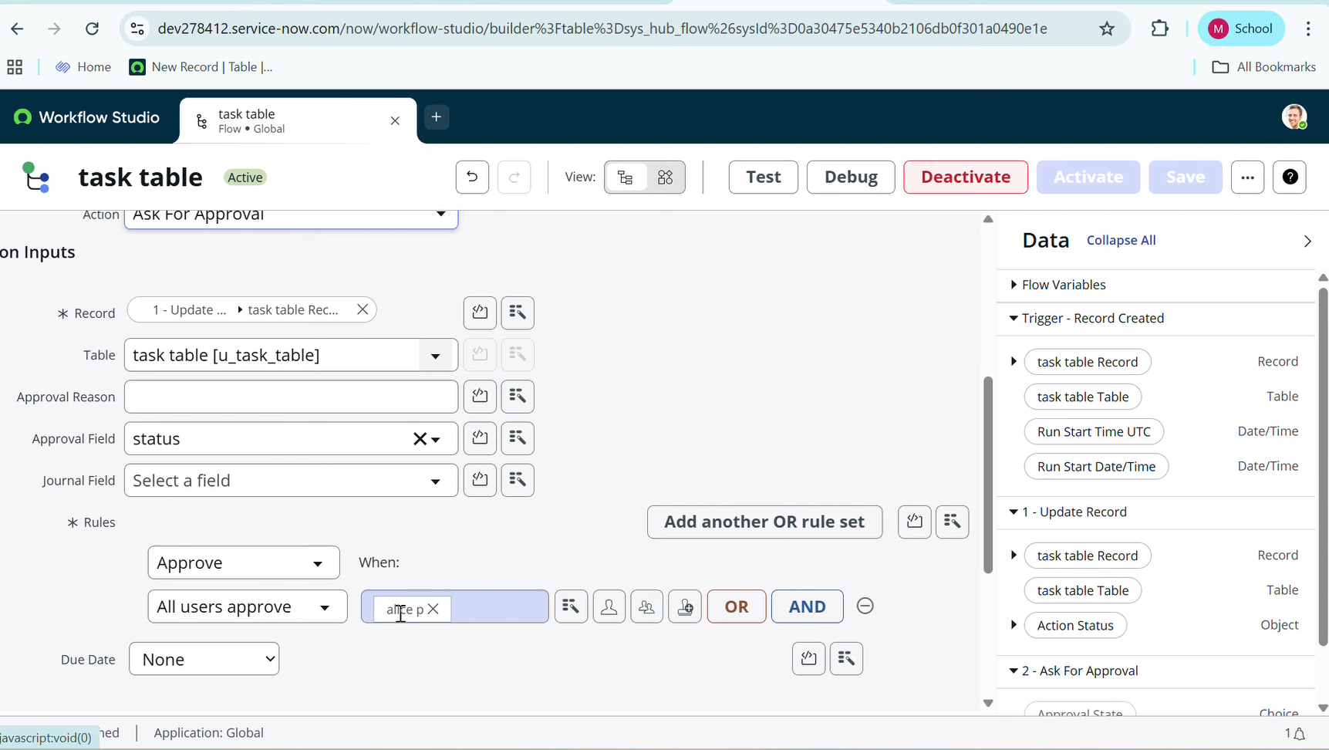

Parameter | Values
Model Summary | Tests the approval and notification workflow during user, group, or role modification. Ensures actions trigger proper review, approval, and audit events.
Accuracy | Execution Success Rate – 97%. All approval paths and escalations executed with expected timing and results.
Confidence Score (Rule Effectiveness) | Confidence – 96% workflow execution consistency and timing reliability.

Performance Summary
The system demonstrated high accuracy and consistency, achieving an overall execution success rate of 97–98% across all test scenarios. Confidence scores confirm strong rule enforcement, ensuring secure access management and smooth workflow operations.
This testing phase confirms that the Optimized User, Group, and Role Management System is production-ready, providing enhanced security, reliability, and administrative efficiency within automated access control workflows.

